**EE 414 Lab 3 Report:**

**Amplifier Design**

**Due: October 8, 2021**

**By: Julio Torres, Jonathan Leisinger, and Prince Tshombe**

**Introduction**

For our third lab in EE414 we had to design an amplifier with the BFR182 bipolar transistor at a frequency of 1.1GHz. We are required to use the 1206 package resistors and capacitors and the 0603 package inductors.

| **Specification** | **Requirements** | **Design Performance** |
| --- | --- | --- |
| **Frequency** | **1.1GHz** | **1.1GHz** |
| **Gain(dB(S(2,1)))** | **11.2 dB** | **10.396** |
| **Input Return Loss dB(S11)** | **Below -15dB** | **-28.4 dB** |
| **Output Return LossdB(S22)** | **Below -15dB** | **-24.8** |
| **Bandwidth** | **Fo +/- 5MHz** | **Fo +/- 5MHz** |
| **Stability (Freq Range)** | **10MHz - 6GHz** | **10MHz - 6GHz** |
| **Bias** | **VCE = 8V**  **IC = 10 mA** | **VCE = 8V**  **IC = 10 mA** |

**Part 1: Stability At Design Frequency**

The transistor was stable at our design frequency. The final value of u at our design frequency is **2.65.**

**Part 2: Simulation Conjugate Matching:**

**List of calculated values for ZS, ZL, Zin, and Zout:**

| **Zs = 13.2210 - j4.3851** | **ZL = 65.014 + j153.18** |
| --- | --- |

| **Zin = 13.2210 + j4.3851** | **Zout = 65.014 - j153.18** |
| --- | --- |

**List Values for the S-Parameters Before and After Matching Network at 1.1GHz**

|  | **S11** | **S21** | **S22** |
| --- | --- | --- | --- |
| **Before MN** | **0.064 + j0.054** | **1.373 + j3.393** | **0.475 - j0.270** |
| **After MN** | **-3.74E-4 - j0.002** | **1.817 - j4.416** | **0.002 - j3.416E-4** |

**Part 3: Design Summary**

**Amplifier Schematic:**

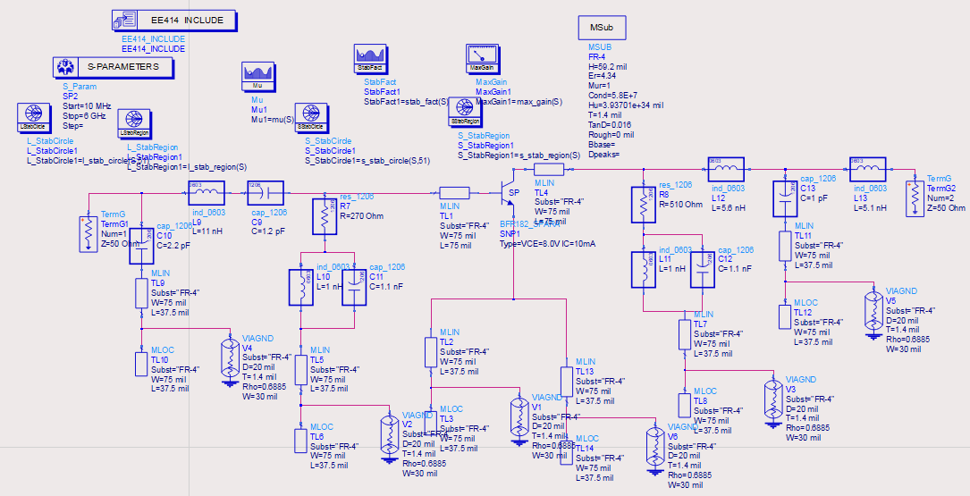

**MU Plot**

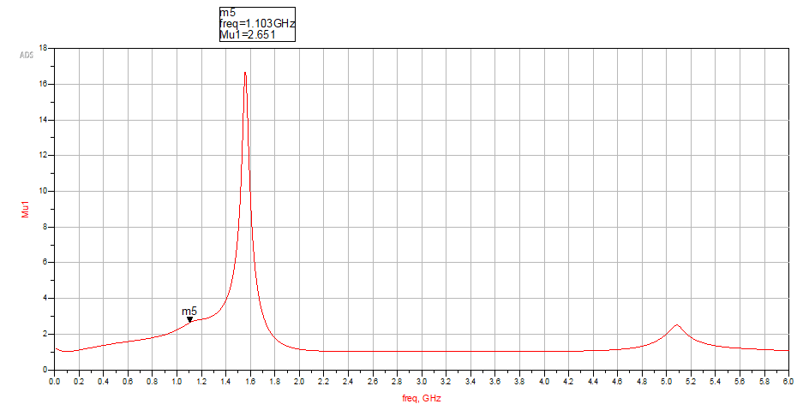

**S21 and Max Gain Plot**

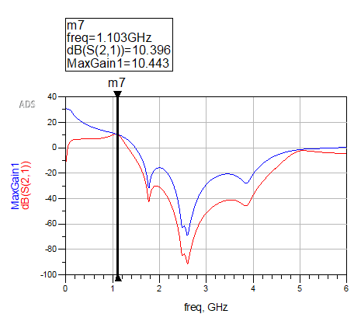

**S11 and S22 Plot**

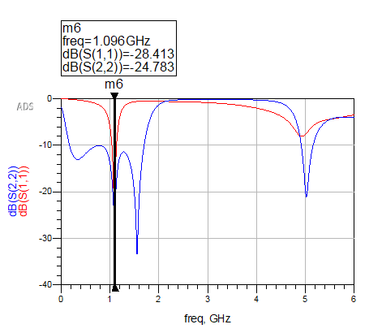

**Part 4: Discussion**

1. Our first problem when running our matlab code was that we weren't getting a good load or source reflection. Our problem here was that the S parameter we got in ADS simulation we had to convert it to real and imaginary.

2. Our second problem occurred in week 2 of lab 3, we had already done the matching networks for input/output and stabilized the amplifier in the frequency range 10 MHz - 6 GHz. When we showed it to our TA, he told us that we had the wrong ZL and Zs. They were too big. To fix this, we had to go back to our matlab code and delete the abs in our reflection formulas.

We had this **rs_minus = abs(B1 - sqrt((B1^2) - (4*abs(C1)^2)))/(2*C1)** and we need this to get the correct ZS **rs_minus = (B1 - sqrt((B1^2) - (4*abs(C1)^2)))/(2*C1).**

**3. Our third problem occurred in the last** week of lab 3, we had already done the matching network, stabilizing the amplifier in the frequency range, dc interface and non ideal grounds. We were having a problem comparing the dBS(1,1) and dBS(2,2) plot.

The professor looked at our schematic and said that everything looked okay, he mentioned that we had an issue with our L matching network values. He looked at our code and saw that in our Qin and Qout we had added abs. Which was wrong because the real(Zin) is not the same as abs(Zin). So after fixing that we got the result that we wanted.

We had this **Qin = (sqrt(((50)/(abs(Zin))- 1))); & Qout = (sqrt((abs(Zout)/50)- 1));**

We need this to get the correct values:

**Qin = (sqrt(((50)/(real(Zin))- 1))); & Qout = (sqrt((real(Zout)/50)- 1));**

**For the Amplifier required specifications:**

We meet all specifications except for the gain; we got it to be 10.4 dB instead of 11.2 dB.

**Appendix**

